**ASSIGNMENT 1**

**TO CASE OF 50 STARTUPS**

1. **R&D SPENDING**

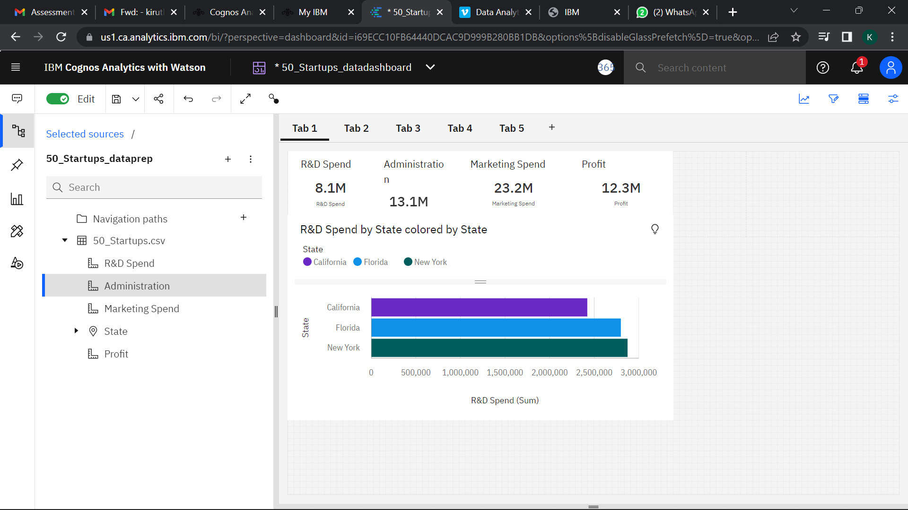

1. **Administration Spending**

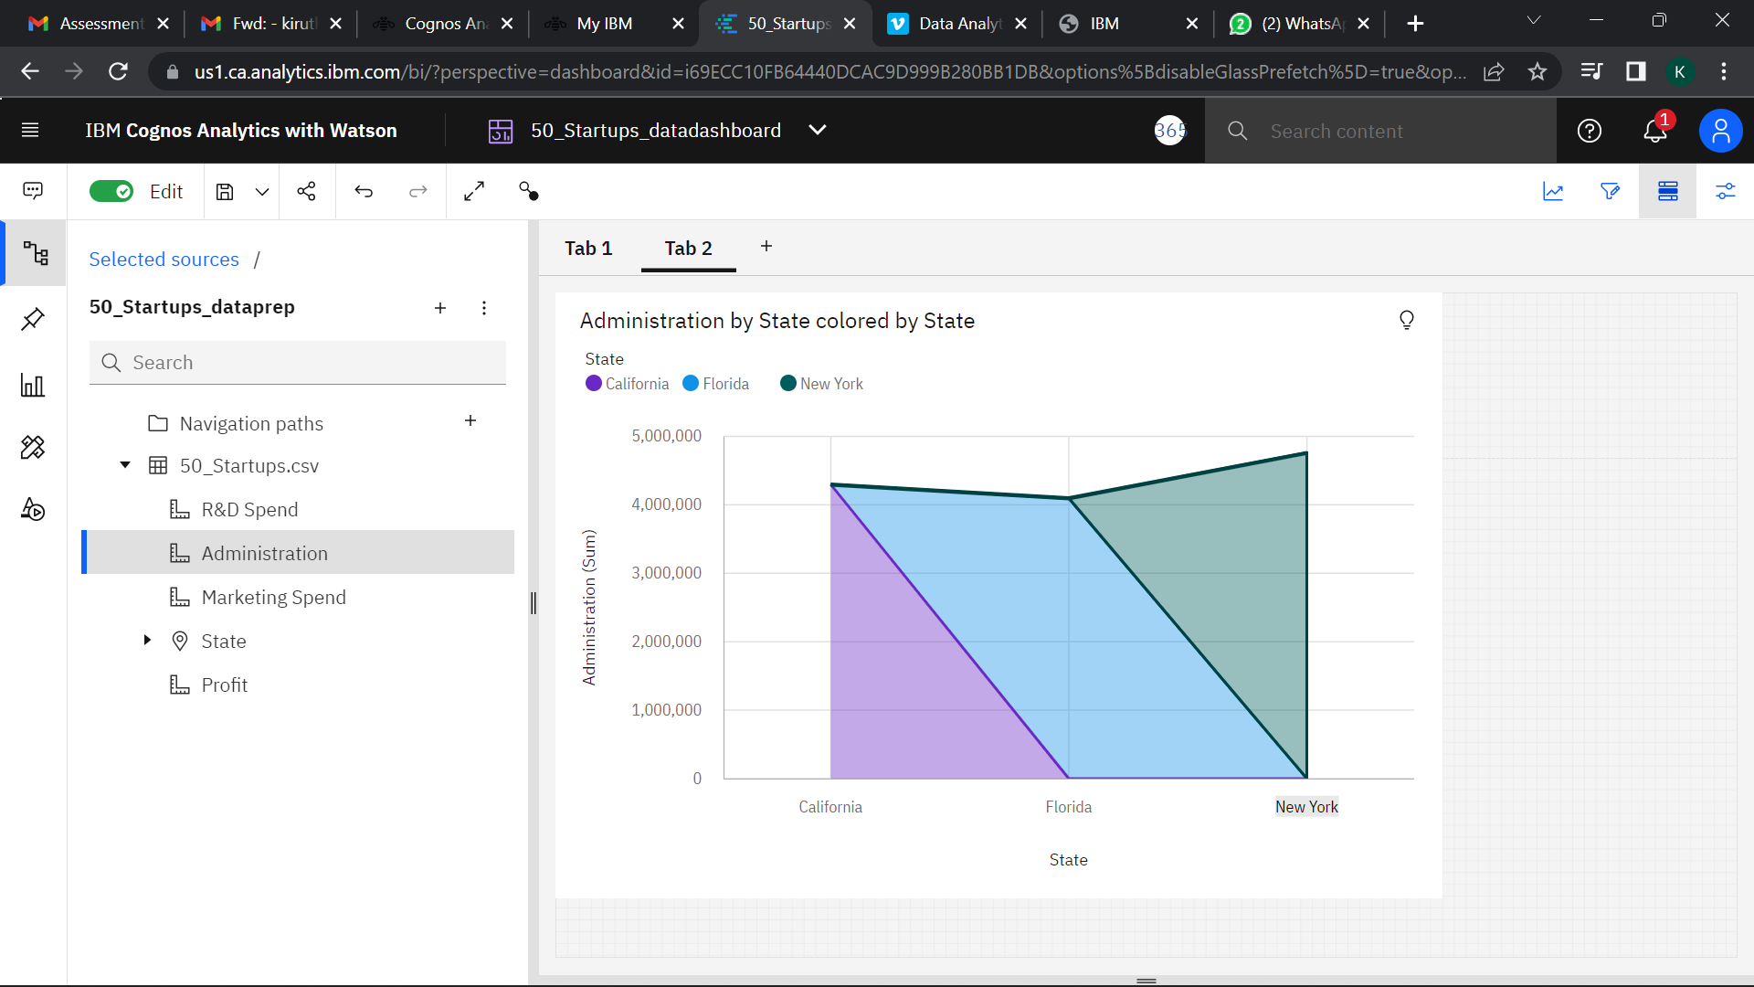

1. **Marketing Spending**

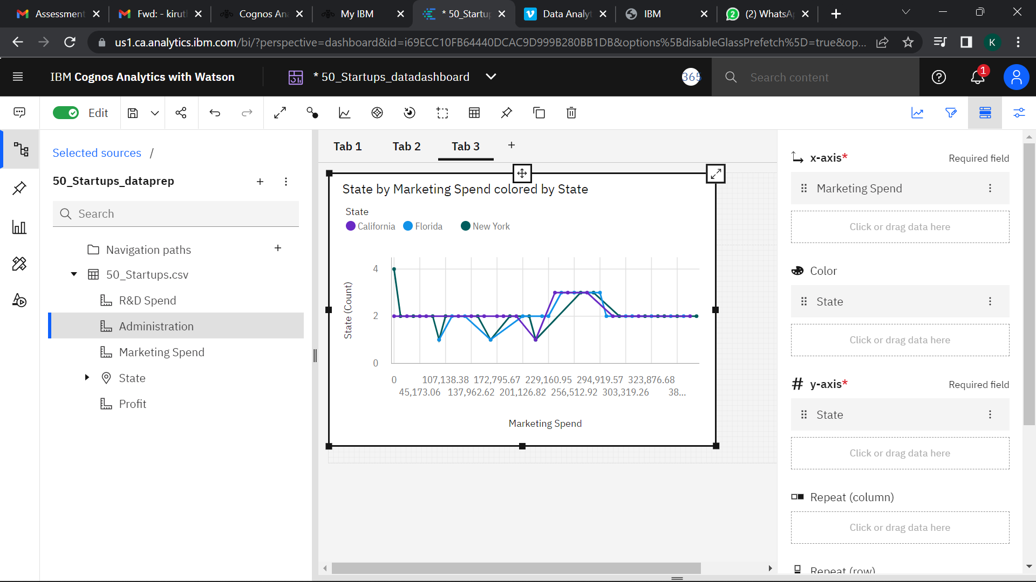

1. **State**

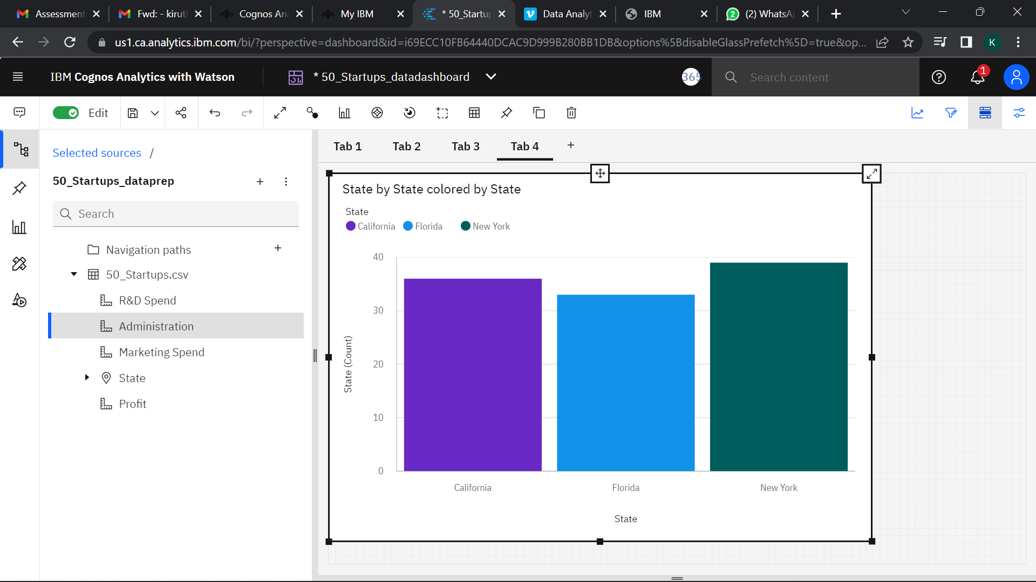

**5.Profit**

